SIMATS ENGINEERING
ASSESSMENT TOOL 1: AI Model Design Exercise
COURSE NAME: | ARTIFICIAL INTELLIGENCE AND EXPERT SYSTEMS | COURSE CODE: | MLA01

COURSE OUTCOME COVERED
CO4: Develop intelligent software agents using suitable agent architectures and learning techniques.(BTL 3)
Assessment Tool Weightage: 40 %
Total Marks: 100 Time: 90 Mins
No. of Questions: 1
Annexure A
AI Model Design Exercise

Code of Conduct:
I Mokshitha Kilari (192525413) (Name / Reg No) certify that this submission is my original work and that I have adhered to the guidelines specified for this assessment.
I understand that any violation of academic integrity rules will result in disciplinary action.
Signature of the student: MOKSHITHAKILARI
Criterion | Weightage | Marks Obtained
1. Problem Analysis and Domain Understanding | 10%
2. Dataset Selection and Data Understanding | 10%
3. Data Preprocessing and Feature Engineering | 10%
4. AI Technique Selection and Justification | 10%
5. Model Design / Architecture | 10%
6. Algorithm / Pseudocode Development | 5%
7. Model Implementation and GitHub Repository | 15%
8. Experimental Design and Results | 10%
9. Performance Evaluation and Metrics | 10%
10. Result Analysis and Interpretation | 5%
11. Limitations and Future Enhancements | 5%
12. Documentation and Technical Presentation | 10%
Total | 100%

Signature of the Faculty Total Marks Awarded

ANSWER ANY ONE QUESTION

S.No. | Scenario / Problem Statement | AI Model / Technique to be Developed | Expected Development Outcome
1 | Smart Loan Approval:  A bank wants to automatically determine whether a customer is eligible for a loan using income, credit score, employment status, loan amount, and repayment history. | Decision Tree | Design and implement a decision-tree-based AI model and determine the most suitable attribute-selection measure such as Information Gain, Gain Ratio, or Gini Index.
2 | Student Performance Prediction:  A university wants to predict whether a student is likely to pass or fail a course using attendance, internal marks, assignment performance, study hours, and previous academic performance. | Inductive Learning | Construct a predictive model from training examples and derive generalized decision rules from the learned patterns.
3 | Disease Risk Prediction:  A healthcare system needs to classify patients into low-risk and high-risk categories based on clinical measurements. | Statistical Learning | Design a statistical learning model, train it using patient data, and evaluate its generalization ability on unseen data.
4 | Image Recognition System:  An organization wants to automatically classify images into categories such as vehicles, animals, and buildings. | Neural Network | Design and implement a neural-network classifier by specifying the network architecture, activation functions, loss function, optimizer, and training procedure.
5 | Handwritten Character Recognition:  A system must recognize handwritten characters from scanned images. | Multilayer Neural Network | Develop a multilayer neural network and demonstrate how backpropagation updates weights to minimize classification error.
6 | Non-Linear Classification:  A dataset contains two classes that cannot be separated using a straight-line decision boundary. | SVM with Kernel Method | Design an SVM-based classifier using an appropriate kernel function and justify the selected kernel based on the characteristics of the dataset.
7 | Intelligent Recommendation Agent:  An online platform wants an agent that learns which recommendations to provide based on user responses. | Reinforcement Learning | Design an RL model by defining the states, actions, rewards, policy, and learning strategy, and demonstrate how the agent learns from user feedback.
8 | Autonomous Game Agent:  An AI agent must learn to play a game where successful actions receive positive rewards and unsuccessful actions receive penalties. | Reinforcement Learning | Develop an RL-based game agent and demonstrate how its policy and performance improve through repeated interaction with the environment.
9 | Explainable Diagnosis System:  A medical AI system predicts a disease but must also provide an explanation for its prediction. | Explanation-Based Learning | Design an explanation-based learning approach using domain knowledge and training examples to generate an understandable justification for the prediction.
10 | AI Model Selection Challenge:  A company provides a dataset for predicting customer churn. | Comparative AI Model Design | Design and compare at least two learning approaches from decision trees, statistical learning, neural networks, or kernel methods. Select the best model based on accuracy, interpretability, computational requirements, and generalization ability.

Structure of the Report:

S.No. | Report Component | What the Student Should Include
1 | Problem Statement | Clearly describe the real-world problem, input data, expected output, and AI task to be solved.
2 | Objectives | State the specific goals of developing the AI model and expected outcomes.
3 | Dataset Description | Provide dataset source, number of instances, features, target variable, data types, and important attributes.
4 | Data Preprocessing | Explain data cleaning, missing-value handling, encoding, normalization/scaling, feature selection, and train-test splitting.
5 | Selected AI Technique and Justification | Identify the selected AI technique and justify its suitability for the problem.
6 | Model Design / Architecture | Present the model structure, components, input/output, parameters, hyperparameters, and architecture/flow diagram.
7 | Algorithm / Pseudocode | Provide the algorithmic steps or pseudocode showing model training and prediction/decision-making.
8 | Implementation | Provide programming language, libraries/tools, important code sections, and implementation details.
9 | Experimental Results | Present results using tables, graphs, sample predictions, learning curves, confusion matrices, or other relevant outputs.
10 | Performance Evaluation | Evaluate the model using appropriate performance metrics such as accuracy, precision, recall, F1-score, MSE, RMSE, or cumulative reward.
11 | Result Analysis | Interpret results, identify important patterns, compare actual and predicted outcomes, and discuss strengths and weaknesses.
12 | Limitations | Discuss limitations related to dataset, model complexity, computational resources, accuracy, generalization, or deployment.
13 | Future Enhancements | Suggest improvements such as additional data, feature engineering, hyperparameter tuning, alternative algorithms, or deployment.
14 | Conclusion | Summarize the problem, methodology, major findings, model performance, and overall effectiveness.
15 | References | List datasets, research papers, books, websites, documentation, libraries, and other sources used.
16 | GitHub Repository Link | Provide the public GitHub repository URL containing the complete source code, dataset information/source, implementation, results, README, and supporting files.

1. Domain Analysis
Selected scenario: Cybersecurity Threat Diagnosis System. A Security Operations Center (SOC) receives events such as repeated login failures, unusual network/login locations, privilege escalation, suspicious file activity and unauthorized access attempts. The required outcome is a rule-based expert system that identifies possible cybersecurity threats and recommends appropriate actions. The assignment specifies SWI-Prolog and requires production rules plus forward and backward chaining. fileciteturn5file0L46-L78

1.1 Problem definition
The system acts as a defensive decision-support expert system. It receives security observations for an incident, matches them against a knowledge base, derives one or more threat classifications, recommends containment or response actions, and provides a reasoning trace that an analyst can inspect.

1.2 Domain entities
- Incident – the security event being assessed.
- User/account – identity involved in authentication activity.
- Endpoint – workstation/server associated with suspicious activity.
- Network – source/destination communication environment.
- File/resource – object involved in suspicious access.
- Threat – inferred security condition such as credential attack or network intrusion.
- Response action – recommended defensive step such as MFA reset, containment or endpoint isolation.

1.3 Inputs, conditions and goals
Category | Examples | Role
Input facts | Repeated failed logins; unusual location; privilege escalation; suspicious file access; abnormal traffic | Initial observations
Intermediate conclusions | Credential attack; account compromise; unauthorized file access; network intrusion | Derived by rules
Final conclusion | High-priority incident | Combines major threat indicators
Actions | Reset MFA; contain account; isolate endpoint; preserve logs; escalate to SOC | Response recommendations

2. Knowledge Acquisition & Representation
Knowledge was structured from the scenario requirements and standard defensive incident-response practice. The assessment itself requires facts, production rules, inference design, testing, evaluation and documentation as development stages. fileciteturn5file0L80-L118

2.1 Knowledge specification
The following knowledge is encoded as facts and rules. A rule is only a diagnostic hypothesis: the presence of indicators does not independently prove that an attack occurred.
- Repeated failed logins + unusual login location → credential attack.
- Unusual login location + privilege escalation → account compromise.
- Suspicious file access + unusual login location → unauthorized file access.
- Abnormal network traffic + suspicious file access → network intrusion.
- Account compromise + network intrusion → high-priority incident.
- Each threat maps to a defensive action, and high-priority incidents are escalated.

2.2 Knowledge representation
incident(inc001, yes, yes, yes, yes, yes).

repeated_failed_logins(I) :- incident(I,yes,_,_,_,_).
unusual_login_location(I) :- incident(I,_,yes,_,_,_).
privilege_escalation(I) :- incident(I,_,_,yes,_,_).

3. Production Rule / Knowledge Base Design
The rule base is deliberately layered: observations produce intermediate threat hypotheses; threat hypotheses produce a final priority classification; classifications produce defensive actions. This structure improves traceability and supports both forward and backward reasoning.
Rule | Condition | Conclusion
R1 | IF repeated_failed_logins(I) AND unusual_login_location(I) | THEN credential_attack(I)
R2 | IF unusual_login_location(I) AND privilege_escalation(I) | THEN account_compromise(I)
R3 | IF suspicious_file_access(I) AND unusual_login_location(I) | THEN unauthorized_file_access(I)
R4 | IF abnormal_network_traffic(I) AND suspicious_file_access(I) | THEN network_intrusion(I)
R5 | IF account_compromise(I) AND network_intrusion(I) | THEN high_priority_incident(I)
R6 | IF credential_attack(I) | THEN reset_mfa(I)
R7 | IF account_compromise(I) | THEN contain_account(I)
R8 | IF network_intrusion(I) | THEN isolate_endpoint(I)
R9 | IF unauthorized_file_access(I) | THEN preserve_logs(I)
R10 | IF high_priority_incident(I) | THEN escalate_soc(I)
Knowledge-base consistency: the same predicates and incident variables are reused throughout the rules. This makes the rule base general rather than hard-coded to one individual observation.

4. Prolog Implementation & Programming
The implementation uses SWI-Prolog facts, predicates, variables, rules, unification, backtracking and an explanation facility. The project also contains an explicit forward-chaining procedure so the two inference styles can be demonstrated separately, as required by the assessment. fileciteturn5file0L47-L52
% CO5-AT1 Cybersecurity Threat Diagnosis Expert System
% Tool: SWI-Prolog
:- dynamic known/1.

% ---------------- KNOWLEDGE BASE ----------------
% incident(ID, failed_logins, unusual_location, privilege_escalation,
% suspicious_file_access, abnormal_network_traffic).
incident(inc001, yes, yes, yes, yes, yes).
incident(inc002, yes, yes, no, no, no).
incident(inc003, no, no, yes, yes, no).
incident(inc004, no, no, no, yes, yes).

% ---------------- OBSERVATION PREDICATES ----------------
repeated_failed_logins(I) :- incident(I,yes,_,_,_,_).
unusual_login_location(I) :- incident(I,_,yes,_,_,_).
privilege_escalation(I) :- incident(I,_,_,yes,_,_).
suspicious_file_access(I) :- incident(I,_,_,_,yes,_).
abnormal_network_traffic(I) :- incident(I,_,_,_,_,yes).

% ---------------- PRODUCTION RULES ----------------
threat(credential_attack(I)) :-
repeated_failed_logins(I), unusual_login_location(I).

threat(account_compromise(I)) :-
unusual_login_location(I), privilege_escalation(I).

threat(unauthorized_file_access(I)) :-
suspicious_file_access(I), unusual_login_location(I).

threat(network_intrusion(I)) :-
abnormal_network_traffic(I), suspicious_file_access(I).

threat(high_priority_incident(I)) :-
account_compromise(I), network_intrusion(I).

action(reset_mfa(I)) :- credential_attack(I).
action(contain_account(I)) :- account_compromise(I).
action(isolate_endpoint(I)) :- network_intrusion(I).
action(preserve_logs(I)) :- unauthorized_file_access(I).
action(escalate_soc(I)) :- high_priority_incident(I).

% ---------------- EXPLANATION FACILITY ----------------
explain(credential_attack(I)) :-
format('Credential attack: repeated failed logins + unusual login location for ~w.~n',[I]).
explain(account_compromise(I)) :-
format('Account compromise: unusual login location + privilege escalation for ~w.~n',[I]).
explain(unauthorized_file_access(I)) :-
format('Unauthorized file access: suspicious file access + unusual location for ~w.~n',[I]).
explain(network_intrusion(I)) :-
format('Network intrusion: abnormal network traffic + suspicious file access for ~w.~n',[I]).
explain(high_priority_incident(I)) :-
format('High priority: account compromise + network intrusion for ~w.~n',[I]).

% ---------------- BACKWARD CHAINING ----------------
diagnose(I,Threat) :-
threat(Threat0), Threat=Threat0,
Threat0 =.. [_,I].

backward_diagnosis(I,Goal) :-
format('GOAL: ~w~n',[Goal]),
( call(Goal) ->
writeln('RESULT: YES'),
explain_goal(I,Goal)
; writeln('RESULT: NO')
).

explain_goal(I,high_priority_incident(I)) :-
writeln('TRACE: high_priority_incident <- account_compromise AND network_intrusion'),
writeln('TRACE: account_compromise <- unusual_location AND privilege_escalation'),
writeln('TRACE: network_intrusion <- abnormal_network_traffic AND suspicious_file_access').
explain_goal(I,account_compromise(I)) :-
writeln('TRACE: account_compromise <- unusual_location AND privilege_escalation').
explain_goal(I,network_intrusion(I)) :-
writeln('TRACE: network_intrusion <- abnormal_network_traffic AND suspicious_file_access').
explain_goal(_,_) :- true.

% ---------------- EXPLICIT FORWARD CHAINING ----------------
forward_chain(I,FinalFacts) :-
retractall(known(_)),
assert_initial(I),
forward_round,
findall(F,known(F),Raw),
sort(Raw,FinalFacts).
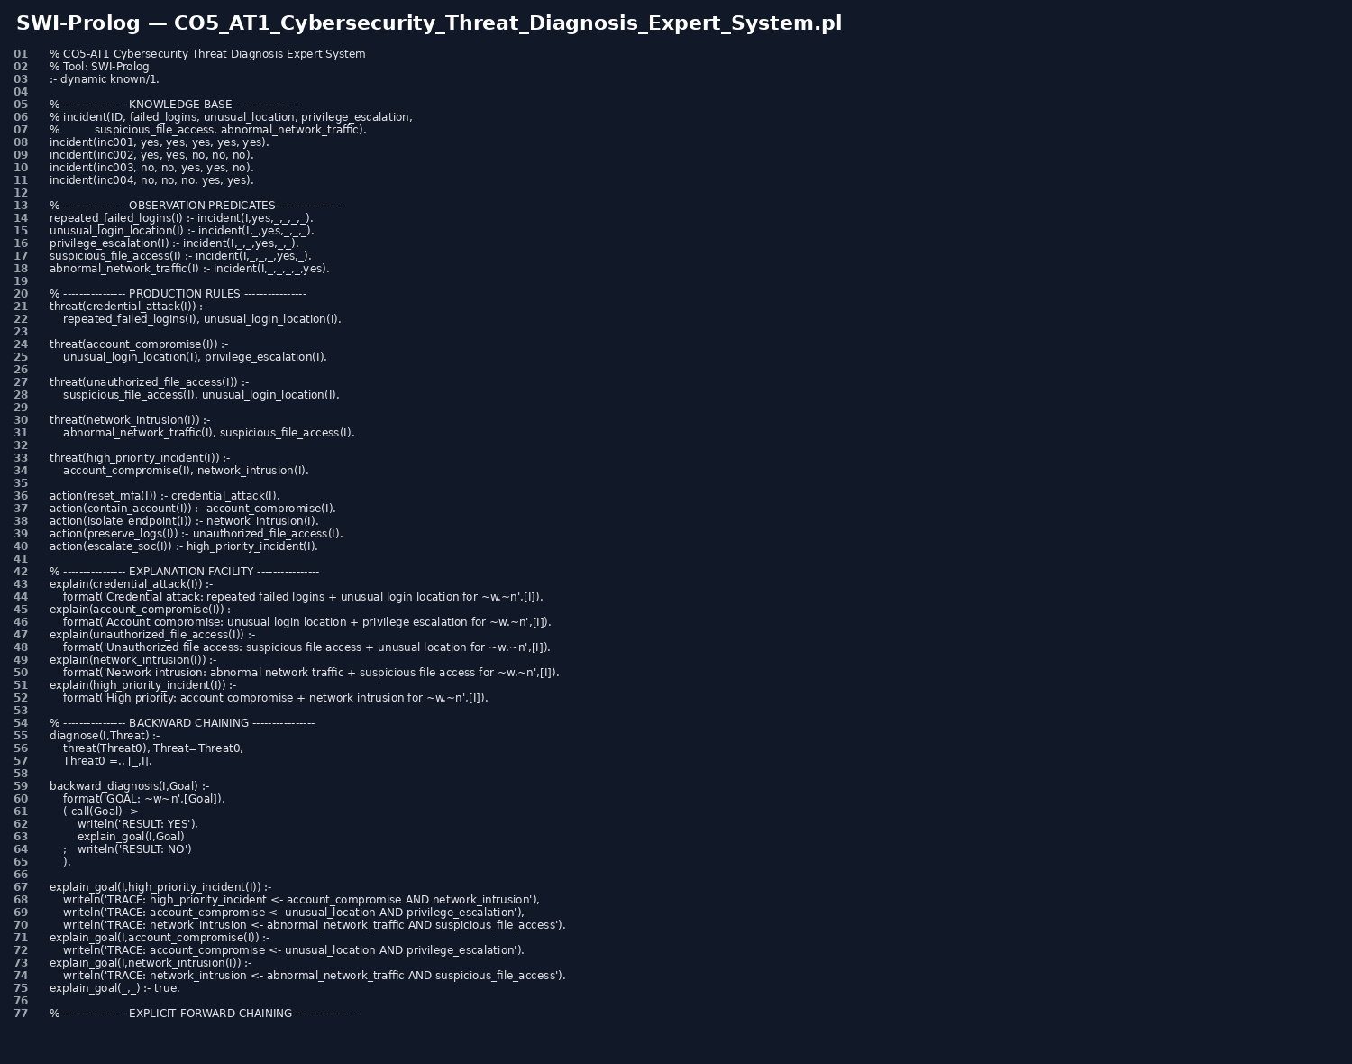
Figure 1: Prolog source-code evidence.
Important queries:
?- show_threats(inc001).
?- show_actions(inc001).
?- backward_diagnosis(inc001, high_priority_incident(inc001)).
?- forward_chain(inc001,Facts).

4.1 Explanation facility
The explain/1 predicates provide a human-readable reason for each derived threat. This is important for expert systems because an analyst should be able to understand why a conclusion was generated rather than receiving only a label.

5. Forward Chaining Implementation & Demonstration
Forward chaining is data-driven. The engine starts from known observations, derives every rule conclusion whose premises are satisfied, adds new conclusions to the working memory, and repeats until no new facts remain.
- Initial facts for inc001: failed logins, unusual location, privilege escalation, suspicious file access and abnormal network traffic.
- R1 derives credential_attack(inc001).
- R2 derives account_compromise(inc001).
- R3 derives unauthorized_file_access(inc001).
- R4 derives network_intrusion(inc001).
- R5 derives high_priority_incident(inc001).
- R6–R10 derive the five corresponding response actions.
- The engine stops when another pass adds zero new facts.
This directly matches the rubric's requirement that forward chaining proceed from initial facts through applicable rules to final conclusions. fileciteturn5file0L241-L269

6. Backward Chaining Implementation & Demonstration
Backward chaining is goal-driven. Instead of generating every possible conclusion, the analyst starts with a goal such as high_priority_incident(inc001). Prolog searches for a rule that can prove that goal and recursively attempts to prove the required premises.
Goal: high_priority_incident(inc001)
<- account_compromise(inc001) AND network_intrusion(inc001)
<- unusual_login_location(inc001) AND privilege_escalation(inc001)
<- abnormal_network_traffic(inc001) AND suspicious_file_access(inc001)
All required base facts are true -> GOAL SUCCEEDS
Backward reasoning is efficient when an analyst has a specific hypothesis to verify. It also produces a natural explanation path from the goal back to the observations, satisfying the rubric's requirement for a clearly traced goal-driven inference process. fileciteturn5file0L270-L297
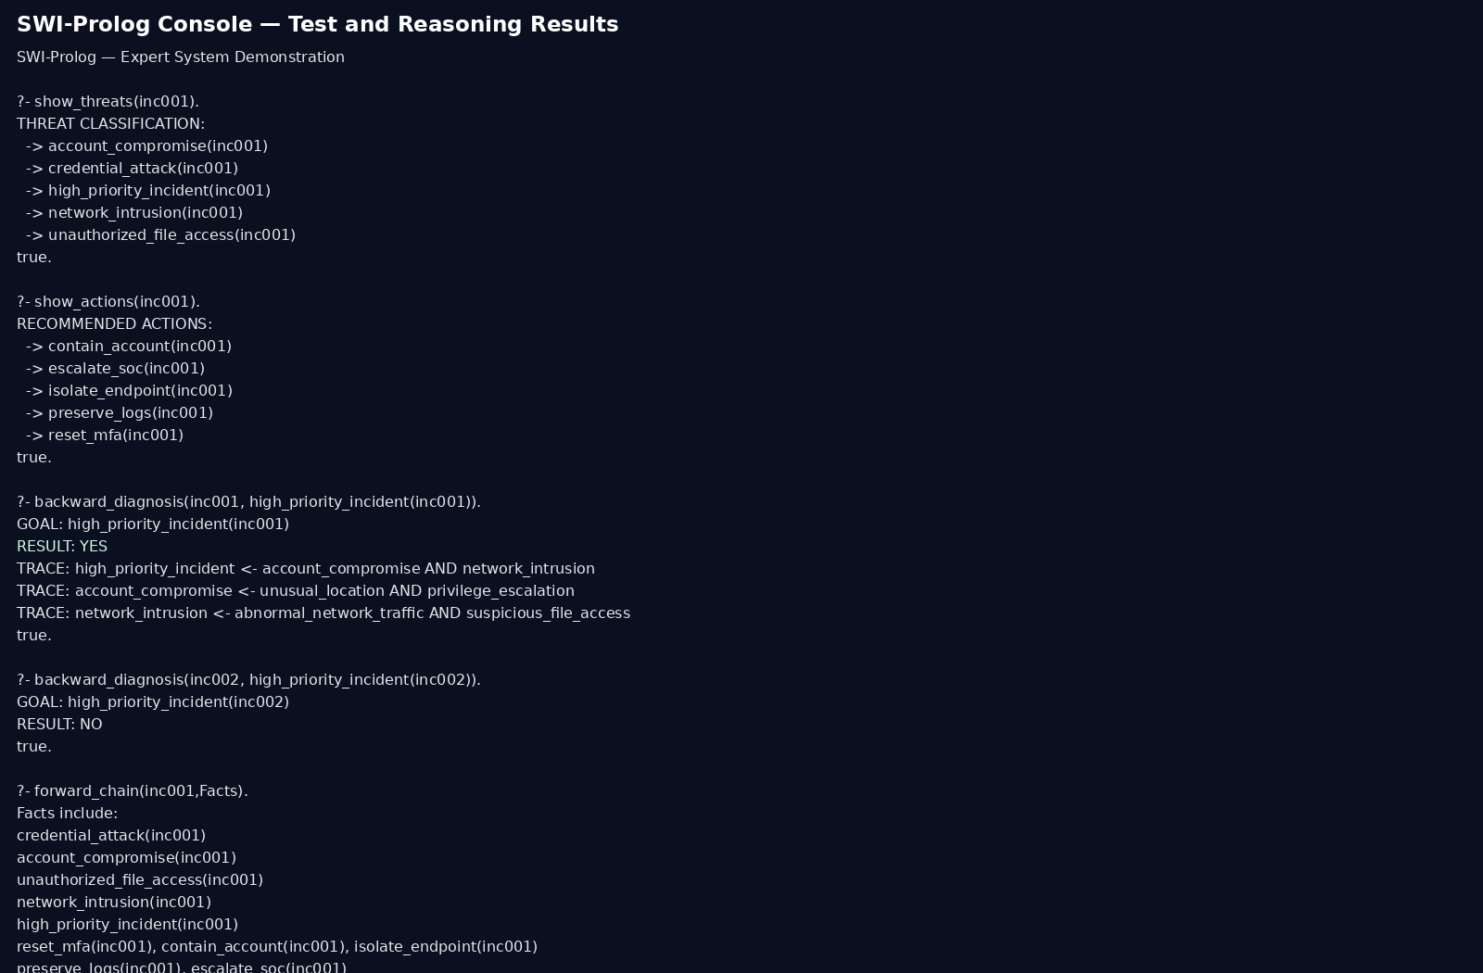
Figure 2: Prolog test and reasoning transcript.

7. Procedural and Non-Procedural Paradigm Analysis
Procedural programming tells the computer how to perform a task through explicit control flow. A procedural implementation would normally specify the order of reading observations, checking conditions, updating state and printing conclusions. Prolog is primarily declarative/non-procedural: the programmer states facts and relationships, while the Prolog engine determines how to search for a proof using unification, backtracking and logical inference.
Aspect | Procedural approach | Prolog / non-procedural approach
Knowledge | Stored as variables/data structures | Stored as facts and rules
Control | Programmer specifies sequence | Engine searches for logical solutions
Rule evaluation | Explicit IF/ELSE or loops | Rules matched through unification
Backtracking | Usually coded explicitly | Built into Prolog search
Explainability | Requires extra tracing logic | Rule structure naturally supports proof traces
Maintenance | Changing control flow can be intrusive | Rules can be added/modified independently
This project | Possible procedural loop for forward chaining | Native Prolog query reasoning + explicit forward engine
The important distinction is not that Prolog has no execution order; it is that the knowledge is expressed declaratively, while the Prolog inference engine controls the search strategy. This distinction is explicitly required by the assessment rubric. fileciteturn5file0L298-L325

8. Unification, Backtracking & Inference Accuracy

8.1 Unification
Unification matches terms by making their variables consistent. For example, the query threat(credential_attack(X)) can unify with a rule whose head is credential_attack(I), causing X and I to refer to the same incident. This allows one rule to apply to inc001, inc002, inc003 and inc004 without duplicating the rule.
Query: threat(credential_attack(X))
Rule: threat(credential_attack(I)) :- repeated_failed_logins(I), unusual_login_location(I).
Unification: X = I
If both premises succeed for inc001 -> X = inc001

8.2 Backtracking
When a Prolog goal has multiple possible solutions, the engine can return one solution and then backtrack to search for alternatives. The show_threats/1 and show_actions/1 predicates deliberately use failure-driven iteration: after printing one solution, fail causes Prolog to backtrack and search for the next solution.

8.3 Inference accuracy
For inc001, the expected classification is five threat conclusions: credential attack, account compromise, unauthorized file access, network intrusion and high-priority incident. The corresponding actions are MFA reset, account containment, endpoint isolation, log preservation and SOC escalation. For inc002, only repeated failed logins and unusual location are present, so credential attack is derived but high-priority incident is not. This negative test prevents the system from classifying every incident as high priority.
The rubric requires accurate conclusions across diverse test cases using unification, backtracking and logical inference. fileciteturn5file0L326-L351

9. Testing, Results & System Demonstration
Four test incidents are included in the knowledge base so the system can be checked under different combinations of evidence.
Test | F | L | P | S | N
inc001 | Yes | Yes | Yes | Yes | Yes
inc002 | Yes | Yes | No | No | No
inc003 | No | No | Yes | Yes | No
inc004 | No | No | No | Yes | Yes

Expected results
Test case | Expected threat conclusion(s) | Expected action(s)
inc001 | Credential attack; account compromise; unauthorized file access; network intrusion; high priority | Reset MFA; contain account; isolate endpoint; preserve logs; escalate SOC
inc002 | Credential attack | Reset MFA
inc003 | No defined threat from current rule set | No automatic action
inc004 | Network intrusion | Isolate endpoint

Evaluation
- Correctness: rules fire only when their premises are satisfied.
- Coverage: five required event indicators are represented and tested.
- Consistency: each threat maps to a clearly defined action.
- Negative testing: inc002–inc003 show that missing prerequisites prevent unrelated conclusions.
- Reasoning performance: forward chaining may derive more facts than required for a single goal; backward chaining is more focused when a specific hypothesis is being checked.
The assignment's testing rubric expects comprehensive test cases, accurate outputs, reasoning traces and convincing demonstration.

10. System Architecture
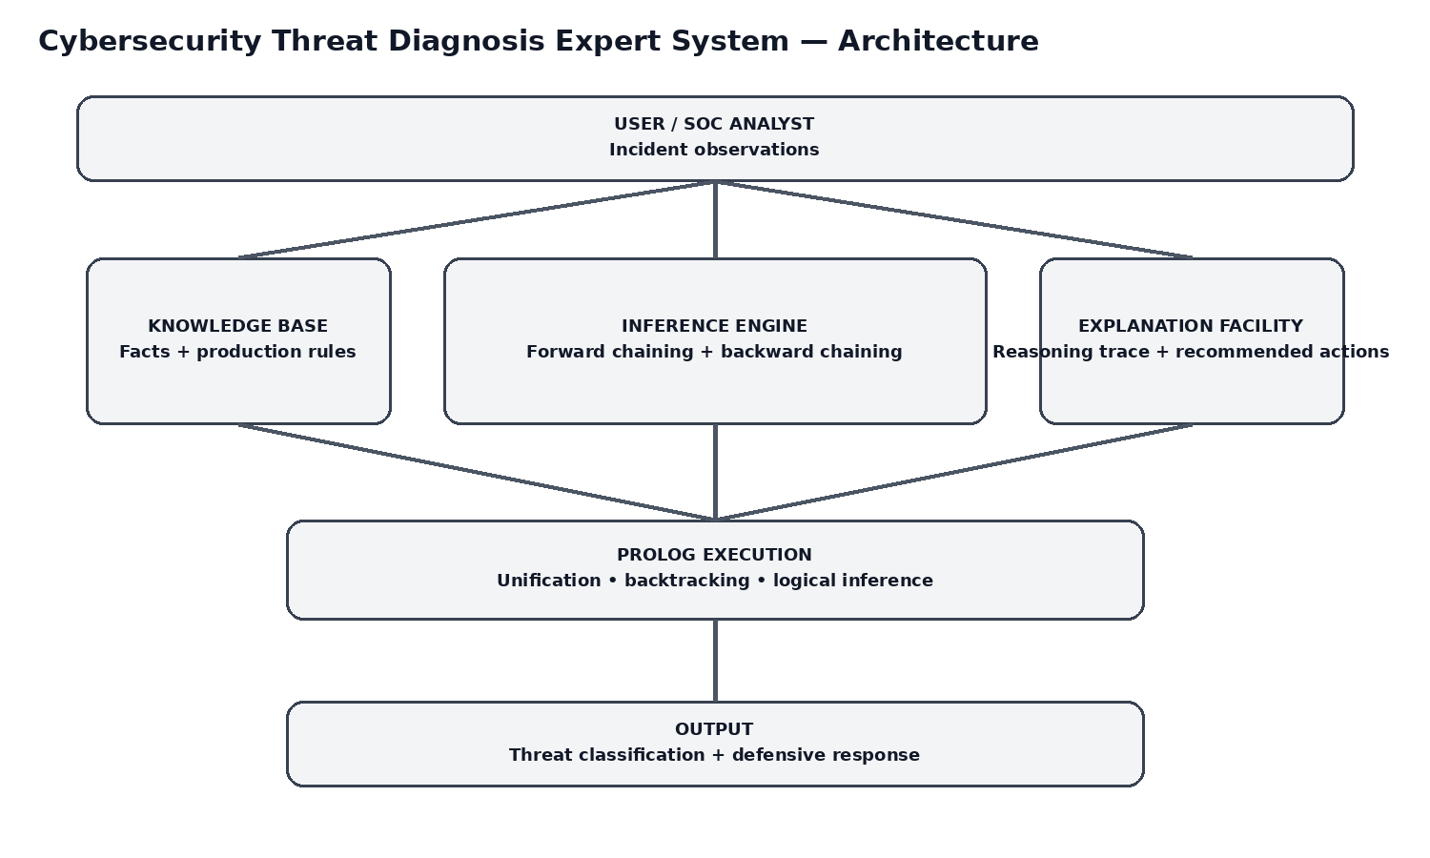
Figure 3: System architecture and inference flow.
System flow: SOC analyst enters incident observations → Prolog knowledge base stores facts → inference engine applies forward or backward reasoning → explanation facility produces the reasoning trace → system returns threat classification and recommended defensive actions.

11. Results, Discussion & Conclusion

11.1 Results
- The system identifies multiple threat categories from combinations of security indicators.
- Forward chaining derives the complete set of consequences from the available evidence.
- Backward chaining efficiently verifies a selected hypothesis and provides a proof trace.
- Prolog unification allows the same rules to operate on multiple incidents.
- Backtracking enables retrieval of multiple applicable threats/actions.
- The explanation facility improves analyst trust and auditability.

11.2 Discussion
The expert system is strongest as an analyst-assistance layer. It converts repeated observable patterns into consistent triage decisions and makes the reasoning explicit. However, a rule-based system cannot determine intent with certainty and should not automatically take disruptive actions without suitable safeguards. In a production SOC, the rules would be supplemented by timestamps, event frequency, asset criticality, user context, threat intelligence and analyst validation.

11.3 Conclusion
The Cybersecurity Threat Diagnosis Expert System successfully models the selected SOC problem using a structured knowledge base and Prolog inference. Production rules provide transparent IF–THEN reasoning, forward chaining provides data-driven classification, and backward chaining provides goal-driven diagnosis. Prolog's unification and backtracking make the rule base reusable across incidents, while the explanation facility provides traceable conclusions. Therefore, SWI-Prolog is an appropriate implementation platform for this rule-based cybersecurity expert-system prototype.

12. Limitations & Future Enhancements
- Current facts are simplified to yes/no indicators.
- No probabilistic confidence score is included.
- No live SIEM, EDR or firewall integration is included.
- Large-scale rule bases may need rule priorities and conflict resolution.
- Future versions can add timestamps, severity scores, asset criticality, user-risk context, MITRE ATT&CK mappings, SIEM integration, alert correlation and a web dashboard.

13. GitHub Repository & Technical Documentation
The assessment requires technical documentation and a GitHub repository. fileciteturn5file0L103-L118 The recommended repository structure is:
CO5_AT1-Cybersecurity-Expert-System/
├── CO5_AT1_Cybersecurity_Threat_Diagnosis_Expert_System.pl
├── README.md
├── docs/
│ ├── domain_analysis.md
│ ├── knowledge_base.md
│ ├── testing_results.md
│ └── screenshots/
└── test_cases/
GitHub URL: ________________________________ (paste the actual public repository URL after creating it.)
Presentation checklist: explain the domain, show the facts/rules, run a forward-chaining query, run a backward-chaining query, demonstrate a negative test, explain unification/backtracking, and discuss procedural versus non-procedural programming.

14. Rubric Coverage Matrix
Rubric criterion | Evidence in this submission
1. Problem Analysis and Domain Understanding – 10% | Sections 1 and 1.3 define the real-world SOC problem, entities, facts, conditions, goals and conclusions.
2. Knowledge Acquisition and Knowledge Representation – 10% | Section 2 gives a knowledge specification and Prolog representation.
3. Production Rule / Knowledge Base Design – 15% | Section 3 provides 10 layered, consistent production rules.
4. Prolog Implementation and Programming – 15% | Section 4 provides facts, predicates, variables, rules, explanation facility and complete .pl source.
5. Forward Chaining – 10% | Section 5 provides the explicit algorithm, derivation sequence and implementation.
6. Backward Chaining – 10% | Section 6 provides goal-driven proof tracing and Prolog query demonstration.
7. Procedural and Non-Procedural Paradigm Analysis – 10% | Section 7 gives a direct procedural vs Prolog comparison and explains how each applies to the project.
8. Inference, Unification and Reasoning Accuracy – 10% | Section 8 explains unification/backtracking and includes positive and negative inference cases.
9. Testing, Results and System Demonstration – 5% | Section 9 includes four test cases, expected outputs, evaluation criteria and demonstration evidence.
10. Documentation, GitHub and Technical Presentation – 5% | Section 13 provides repository structure, documentation requirements and presentation checklist.

References
- SIMATS Engineering, MLA01 Artificial Intelligence and Expert Systems, CO5 – Assessment Tool 1: Expert System Development Project.
- NIST Special Publication 800-61 Rev. 2, Computer Security Incident Handling Guide.
- MITRE ATT&CK Enterprise knowledge base, defensive cybersecurity technique and procedure reference.
- SWI-Prolog Documentation, Prolog language reference and execution concepts.

Evaluation Rubrics:

Criterion | Weightage (%) | Excellent | Good | Average | Poor
1. Problem Analysis and Understanding | 10% | 9–10% – Clearly analyzes the real-world problem, objectives, inputs, outputs, constraints, and expected AI outcome. | 7–8% – Understands the problem and objectives with minor omissions. | 5–6% – Shows partial understanding with some important elements missing. | 0–4% – Problem is poorly understood or incorrectly defined.
2. Dataset Selection and Understanding | 10% | 9–10% – Selects a highly relevant dataset and clearly explains features, target, source, size, and characteristics. | 7–8% – Appropriate dataset with adequate description and minor omissions. | 5–6% – Dataset is usable but description or relevance is limited. | 0–4% – Dataset is inappropriate, poorly described, or missing.
3. Data Preprocessing and Feature Engineering | 10% | 9–10% – Performs appropriate cleaning, transformation, encoding, scaling, feature selection, and data splitting with clear justification. | 7–8% – Performs most required preprocessing correctly with minor issues. | 5–6% – Basic preprocessing is performed but important steps are missing. | 0–4% – Preprocessing is inadequate, incorrect, or absent.
4. AI Technique Selection and Justification | 10% | 9–10% – Selects the most appropriate AI technique and provides strong technical justification based on the problem and dataset. | 7–8% – Appropriate technique selected with reasonable justification. | 5–6% – Technique is acceptable but justification is limited. | 0–4% – Inappropriate technique or no meaningful justification.
5. Model Design / Architecture | 10% | 9–10% – Develops a clear, technically sound model architecture with appropriate components, parameters, and workflow. | 7–8% – Model is well designed with minor omissions. | 5–6% – Basic model design is presented but lacks technical depth. | 0–4% – Model design is unclear, incomplete, or inappropriate.
6. Algorithm / Pseudocode | 5% | 5% – Algorithm/pseudocode is complete, logically correct, structured, and clearly represents the model development process. | 4% – Mostly correct with minor omissions. | 2–3% – Basic algorithm provided but contains gaps. | 0–1% – Algorithm is missing or substantially incorrect.
7. Implementation and GitHub Repository | 15% | 13–15% – Fully functional implementation with clean, organized, reproducible code and a complete GitHub repository with README and supporting files. | 10–12% – Functional implementation and well-organized repository with minor issues. | 7–9% – Partially functional implementation or incomplete repository documentation. | 0–6% – Implementation is incomplete/non-functional or GitHub repository is missing.
8. Experimental Design and Results | 10% | 9–10% – Conducts meaningful experiments with appropriate test cases and clearly presents results using tables, graphs, or visualizations. | 7–8% – Appropriate experiments with clearly presented results. | 5–6% – Limited experiments or basic result presentation. | 0–4% – Insufficient, incorrect, or missing experimental results.
9. Performance Evaluation | 10% | 9–10% – Uses appropriate evaluation metrics and provides comprehensive quantitative analysis of model performance. | 7–8% – Uses suitable metrics and provides adequate evaluation. | 5–6% – Basic evaluation with limited metrics or analysis. | 0–4% – Inappropriate metrics or performance evaluation is missing.
10. Result Analysis and Interpretation | 5% | 5% – Provides insightful analysis of results, identifies patterns, errors, strengths, weaknesses, and explains model behavior. | 4% – Provides good interpretation with minor gaps. | 2–3% – Basic interpretation with limited analysis. | 0–1% – Results are not meaningfully analyzed.
11. Limitations and Future Enhancements | 5% | 5% – Clearly identifies realistic limitations and proposes technically relevant and feasible improvements. | 4% – Identifies relevant limitations and reasonable improvements. | 2–3% – Provides basic limitations and future suggestions. | 0–1% – Missing, unrealistic, or poorly explained.
12. Documentation and Technical Presentation | 10% | 9–10% – Report is comprehensive, well organized, technically accurate, professionally presented, and properly referenced. | 7–8% – Well documented with minor presentation or referencing issues. | 5–6% – Adequate documentation with several gaps. | 0–4% – Poorly documented, unclear, or incomplete report.
Total | 100%

